**IQ School ERD**

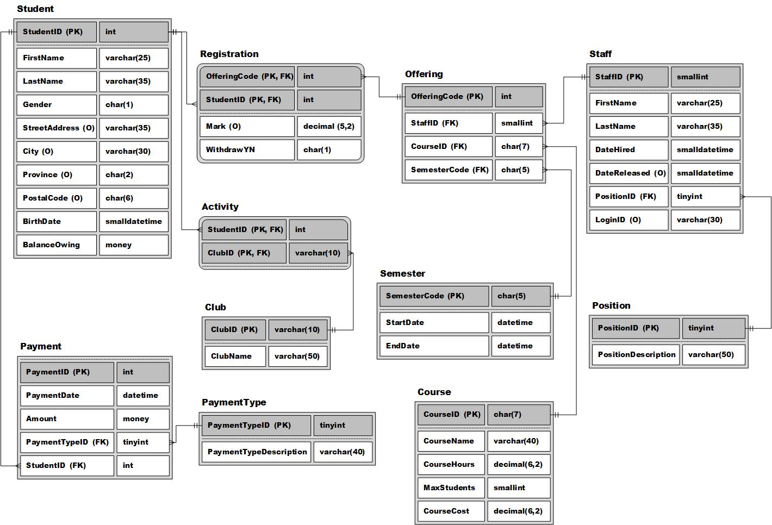

*MaxStudents is the maximum number of students in a particular course each offering